

PROFESSIONAL ETHICS

21LEM202T

PBL (PROJECT BASED LEARNING)

TITLE : FAMILY BUSINESS COMPARED TO MERIT BUSINESS

Introduction

1. Definition and Characteristics

2. Succession: Inheritance vs. Merit

3. Risks and Benefits of Each Model

4. Real-Life & Famous Case Studies

5. Striking a Balance and Recommendations

Conclusion

Presenting the basic flow of the content:

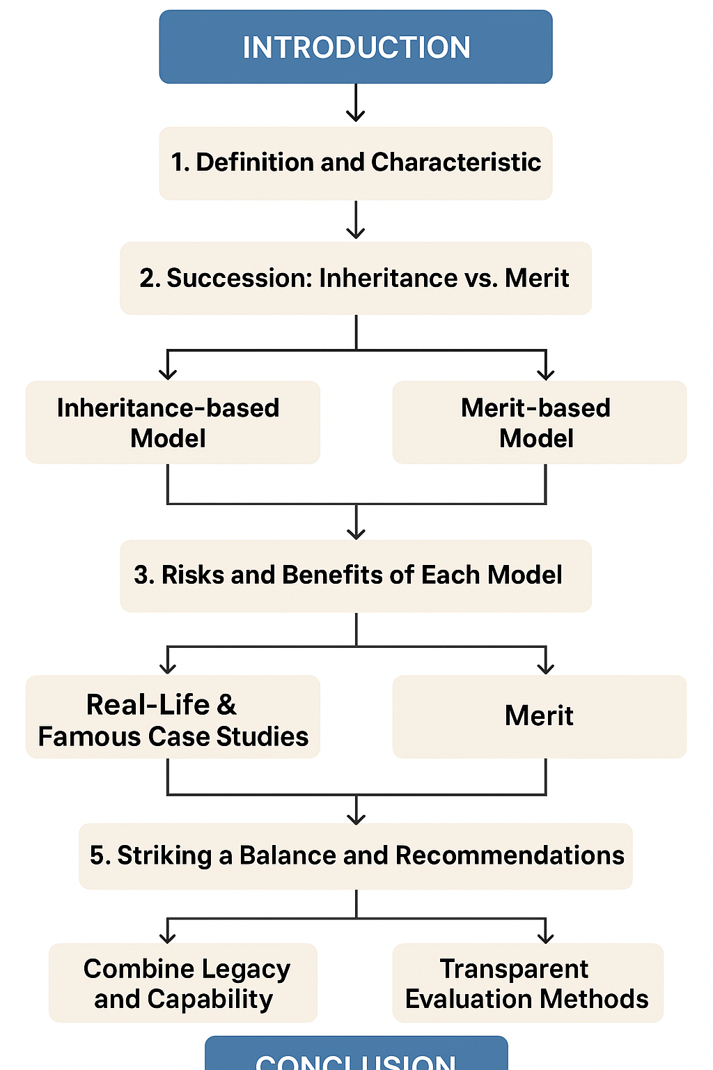

**Detailed Section of the work**

|  |  |  |  |
| --- | --- | --- | --- |
| **Phase** | **Topic** | **Role** | **Key Focus** |
| **Phase 1** | **1. Definition and Characteristics** | **The Corporate Anthropologist** | This section defines the core structural differences between enterprises driven by familial loyalty and those rooted in professional governance. |
| **Phase 2** | **2. Succession: Inheritance vs. Merit** | **The Chief Talent Officer** | We explore the pivotal moment in any business: how leadership is chosen, contrasting birthright with proven competence and skill sets. |
| **Phase 3** | **3. Risks and Benefits of Each Model** | **The Strategic Risk Analyst** | This analysis weighs the inherent stability and deep commitment of family ownership against the accountability and scalability of merit-based management. |
| **Phase 4** | **4. Real-Life & Famous Case Studies** | **The Business Historian** | We review famous examples like Satyam vs. Infosys and Jet Airways vs. IndiGo to see the real-world consequences of each model. |
| **Phase 5** | **5. Striking a Balance and Recommendations** | **The Governance Consultant** | This final section provides actionable strategies for blending familial values with professional ethics to achieve long-term stability and growth. |

*Proposed by:*

*Kevin Bennette RA2411033010099*

*Arun Teja Reddy RA2411033010079*

*Akshat Soni RA2411033010083*

*Harsh Yuvraj RA2411033010096*

*Riddhima Singh RA2411033010107*